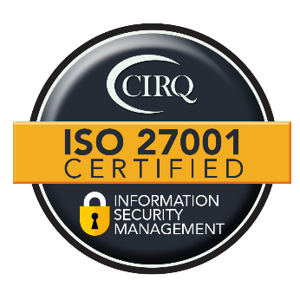
Ironwood Insights Group, LLC
www.ironwoodinsights.com
Contact: Brad Larson - bradlarson@Ironwoodinsights.com
Date: September 14, 2026

For Immediate Release

Ironwood Insights Group Achieves ISO/IEC 27001:2022 Certification for Information Security Management
Chandler, Arizona – September 2026 – Ironwood Insights Group, LLC today announced that it has achieved ISO/IEC 27001:2022 certification for its Information Security Management System (ISMS) through the Certification Institute for Research Quality (CIRQ). As of August 29, 2026, Ironwood is certified for ISO/IEC 27001:2022, the International Standard for Information technology — Security techniques — Information security management systems, with a scope defined in the certification.
The certification reflects Ironwood's continued commitment to maintaining disciplined processes for managing information security across its research and business operations. The certified ISMS encompasses the management and oversight of the corporate infrastructure, systems, and services supporting the design, execution, analysis, and delivery of market and political research, including data collection, data processing, analytics, reporting, and supporting internal business processes.
"Protecting the information entrusted to us is fundamental to the work we do for our clients," said Ironwood CEO, Brad Larson. "Research organizations manage increasingly complex data, technologies, platforms, and workflows, so information security has to be built into how the organization operates, not treated as a separate IT function. Achieving ISO 27001 certification provides our clients with additional confidence that Ironwood has established a disciplined, structured approach to managing information security across our research environment."
Ironwood's certification scope includes the systems and services used throughout its research operations, including Microsoft 365 cloud services, survey programming and panel hosting platforms, and data analysis tools. The certification applies to Ironwood's global ISMS, with its Rexburg, Idaho and Houston, Texas facilities and networking equipment included within the location scope.
For Ironwood clients, the certification represents another layer of rigor within a broader commitment to research quality, data integrity, and responsible technology management. As research organizations increasingly rely on cloud platforms, integrated data sources, artificial intelligence, online sample, and sophisticated analytics, maintaining formal information security processes is an increasingly important component of delivering trusted research.
"Our clients rely on us not only to deliver meaningful insights, but also to manage the research process responsibly," Larson continued. "ISO 27001 certification reinforces the operational standards we have put in place around our technology and information environment. Combined with our continued investments in data quality, respondent verification, research technology, and experienced human oversight, it strengthens the foundation behind the insights we deliver."
About Ironwood
Ironwood Insights Group, LLC, founded in 2017, is a full-spectrum, strategic insights organization; powered by advanced technology and analytics, and driven by a seasoned team of leading industry experts. We design smart, creative research solutions, using industry-leading technology, sampling and data collection platforms and next-level analytical frameworks to deliver decision-ready insights that move businesses forward today and tomorrow. To learn more about Ironwood Insights Group, please visit www.ironwoodinsights.com.

